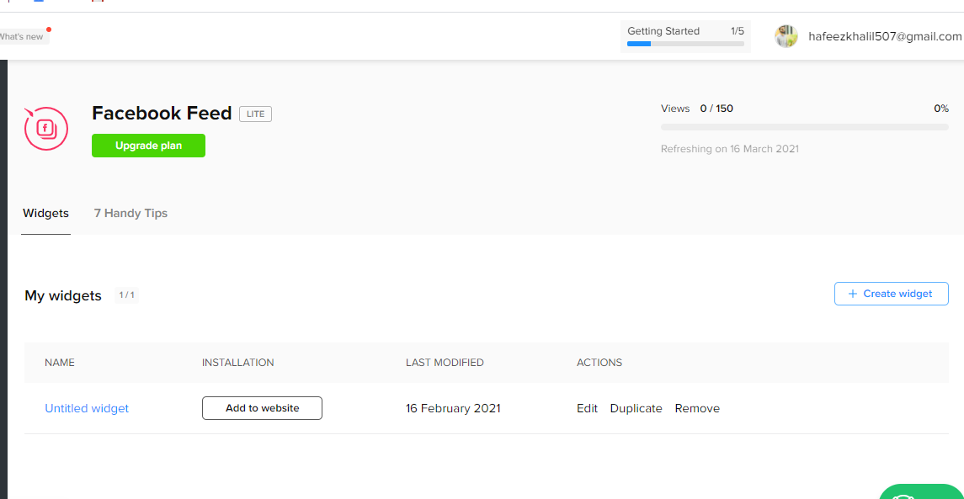

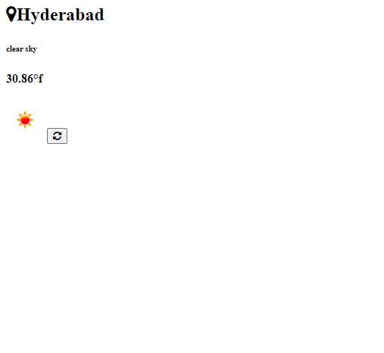

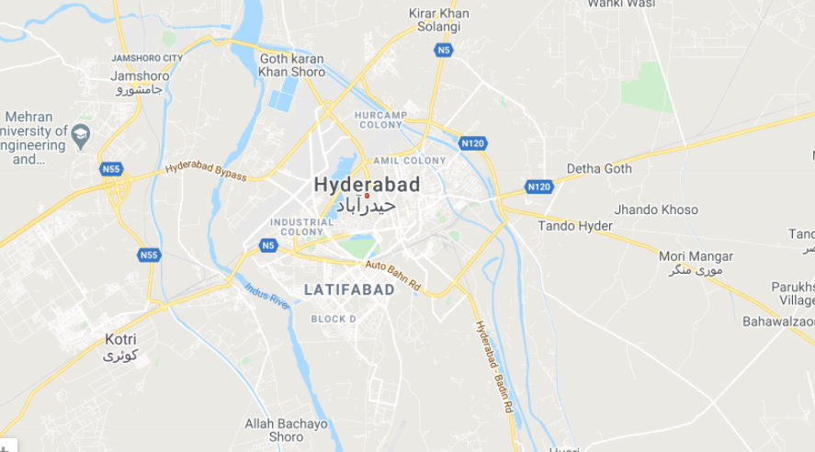

<!DOCTYPE html>

<html>

<head>

<link href="https://maxcdn.bootstrapcdn.com/font-awesome/4.7.0/css/font-awesome.min.css" rel="stylesheet">

<link rel="preconnect" href="https://fonts.gstatic.com">

<link href="https://fonts.googleapis.com/css2?family=Poppins&display=swap" rel="stylesheet">

<title></title>

</head>

<body>

<div class="container">

<div class="card">

<h2><i class="fa fa-map-marker"></i><span id="location"></span></h2>

<h6 id="weather"></h6>

<h4><span id="temp"></span></h4>

<img src="" id="icon">

<button onclick="window.location.reload();" class="refresh"><i class="fa fa-refresh"></i></button>

</div>

</div>

<script type="text/javascript">

link="https://api.openweathermap.org/data/2.5/weather?q=jamhoro&units=metric&appid=9aa51f25956d8a7c5b6a05773c9dfafb";

var request = new XMLHttpRequest();

request.open('GET', link,true);

request.onload = function(){

var obj =JSON.parse(this.response);

console.log(obj);

document.getElementById('weather').innerHTML=obj.weather[0].description;

document.getElementById('location').innerHTML=obj.name;

document.getElementById('temp').innerHTML=obj.main.temp+"°f";

document.getElementById('icon').src="http://openweathermap.org/img /w/"+obj.weather[0].icon+".png";

}

if(request.status==200){

console.log("error");

}

request.send();

</script>

</body>

</html>